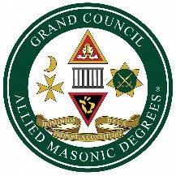

The Grand Council of the Order of the Allied Masonic Degrees of England and Wales and Districts and Councils Overseas

TOAST LIST
After Grace

THE KING
***

Most Worshipful Brother
Thomas Firth Jackson
GRAND MASTER
***

Right Worshipful Brother
Colin Robert Woodcock, MBE
DEPUTY GRAND MASTER

and the rest of the Grand Officers, present and past
***

Right Worshipful Brother
Brian Benjamin Williams
DISTRICT GRAND PREFECT
***
Worshipful Brother
Graham Samuel Kirby P.G.St.B.
DEPUTY DISTRICT GRAND PREFECT

and the rest of the District Grand Officers, present and past
***
The Worshipful Master

***
The Candidate(s)*
(on first entry into the Order)
***

The Visitors* (When applicable)

